The Pauline Hinch Memorial Award for Staff Development at the Toronto Public Library Foundation

Named in memory of Pauline Hinch, this Award recognizes Pauline’s contribution to the Library, through her outstanding career as well as her contribution to the profession of librarianship. It supports Toronto Public Library staff who are pursuing a career in public librarianship.

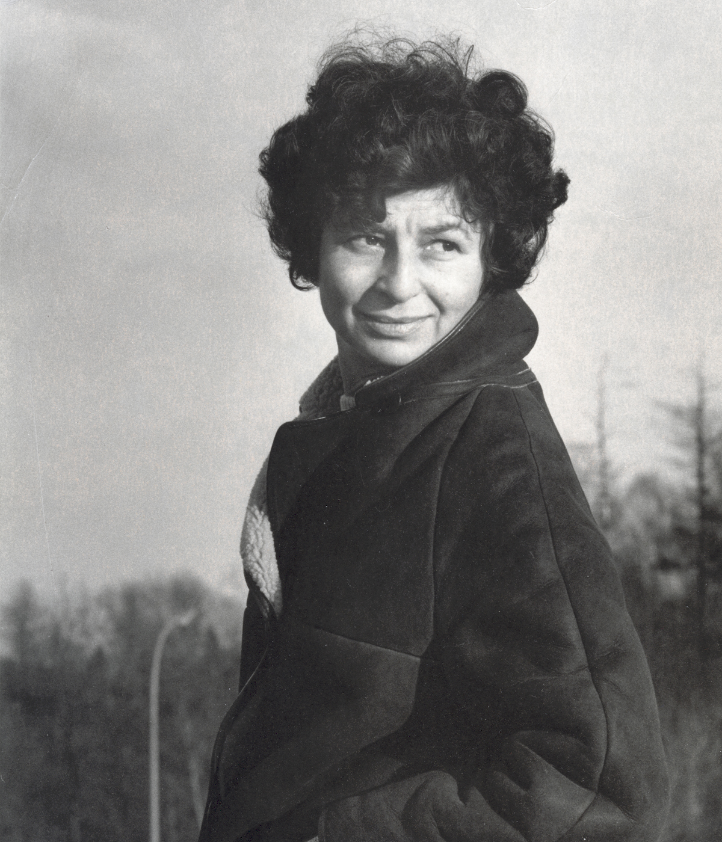
Pauline Hinch was born in Thunder Bay Ontario. Following high school graduation, she had an early career in radio. In mid-life, Pauline went back to school, obtaining her Masters in Library Science in 1975. She joined the North York Public Library, Collection Development Department immediately thereafter. With the opening of the new central library in 1987 she was appointed Manager of Language, Literature and Fine Arts. By her retirement in 1990, she was in charge of the Canadiana and Society and Recreation departments. Her passion for public librarianship and the high standards to which she adhered to earned her the respect and affection of all her colleagues. Working in a world she loved, Pauline sought to nurture this same affection of libraries and its users among everyone with whom she worked.

The Award provides a partial or full (as funds permit) one-year tuition scholarship to Library staff members pursuing qualifications as a librarian (completing their Masters of Library/Information Science degree) in an accredited library science program.

The Award(s) are administered and its recipients chosen, through the Foundation, by
The Pauline Hinch Memorial Award Committee, set up for the sole purpose of administering
the award.

Depending on the funds available for disbursement from the Pauline Hinch Endowment Fund at the Toronto Public Library Foundation and any additional annual funding available, an award will be distributed annually. Each recipient will receive no more than the cost of one year’s tuition and no less than $4,000 per award.

Notice of availability of the award will be made by early March of the disbursement year.

Eligibility Information
Qualified candidates for the award will:
- Be permanent Library staff members who have completed or are in the process of successfully completing a minimum of 4 courses (8 half courses) towards their Master’s of Library Science degree and are committed to completing another 4 courses/8 half courses (and/or completing their degree) at an accredited school within the two-year period following the receipt of the award.
- Have successfully completed the application process for the award.
- Use the award to support their tuition costs
Application Information
- Complete all of the sections of this application. All information must be typed directly on the application form or on additional paper. Handwritten applications will not be considered.

- References must accompany the application. Please do not supply more than two letters of reference. One reference must be from your current Library Service Manager, Area Manager or equivalent.

- Applications must be received no later than Tuesday, May 19, 2020. Please submit completed applications to:
Toronto Public Library Foundation, 789 Yonge Street, Toronto, ON M4W 2G8
Attn: Liza Fernandes, Director, Legacy Gifts

Applications may be submitted via email to lfernandes@tpl.ca using the subject line:
2020 Award Application. The entire application with all components (application, references and transcript) must be submitted in one email.

It is the applicant’s responsibility to ensure the completed application form and supporting documentation are received by the Toronto Public Library Foundation on or prior to the deadline date.

- Successful applicants will be notified by July 31, 2020. A shortlist of candidates will be called for a personal interview with the Award Committee during the month of June.

- The successful applicant may be required to show proof of successful completion of the
4 courses/8 half courses (and/or completion of their degree) following the receipt of the award. If the applicant is unable to provide the necessary proof, the award may be revoked.

Award Criteria
- Applicant fulfills eligibility requirements as listed above
- Applicant can demonstrate a passion for public librarianship
- Consideration will be given to academic standing and financial need.

Dates and Deadlines

Application Deadline: Tuesday, May 19, 2020

All completed applications will be reviewed. A shortlist of candidates will be called for a personal interview with the Committee during the month of June.

Notification Date: Friday, July 31, 2020
The award will be formally distributed at the annual Staff Recognition Event (usually held in November). The successful candidate will make every possible effort to be present at this event.

For more information, please contact Liza Fernandes, Director, Legacy Gifts in the Foundation Office at 416-397-5924 or lfernandes@tpl.ca

Appendices
Application Form, Reference Form

